Lab 6: Complexation Reactions and EDTA Titrations

Introduction
Magnesium is one of the most common divalent cations in natural water, and its concentration sets the hardness of the water — a property that matters for drinking-water quality, boiler scaling in industry, and the activity of magnesium-dependent enzymes in biology. To act on these problems we need a quick, reproducible way to measure $[{\text{Mg}}^{2+}]$ in solutions whose hardness is not known in advance.
In this experiment I measured the concentration of an unknown ${\text{MgCl}}_{2}$ solution two ways. The first was a complexometric titration with EDTA, tracked spectrophotometrically with Calmagite as the visual indicator. EDTA chelates ${\text{Mg}}^{2+}$ in a clean 1:1 stoichiometry and binds it more strongly than Calmagite does, so the indicator switches from its wine-red Mg-bound form to its blue free form exactly when the EDTA has accounted for every magnesium ion in solution — the colour change is the equivalence point, and the volume of titrant directly gives the moles of ${\text{Mg}}^{2+}$. The second method used 8-hydroxyquinoline-5-sulfonic acid (HQS), which forms a fluorescent complex with ${\text{Mg}}^{2+}$. A calibration curve of Mg-HQS fluorescence intensity against $[{\text{Mg}}^{2+}]$ lets me read an unknown’s concentration from a single fluorescence measurement, which is much faster and far more sensitive than titration once the curve has been built.
I chose to run both methods on the same unknown because they fail in different ways. EDTA titration is the analytical reference and works across a wide concentration range, but it consumes a few mL of sample per trial and depends on a clean visual endpoint. HQS fluorescence is sensitive enough for trace-level magnesium and uses very little sample, but it depends on the unknown sitting within the calibrated fluorescence range and on a buffered pH near 8 — outside those windows the calibration breaks down. Comparing the two on the same solution shows which conditions each method tolerates, and how big the disagreement is when one of them is pushed outside its working range. That kind of cross-check is what makes a measured concentration trustworthy, not just internally consistent.

Data Analysis

Part A

Q1. Overlaid absorbance spectra of Mg(II)/Calmagite at each titration point
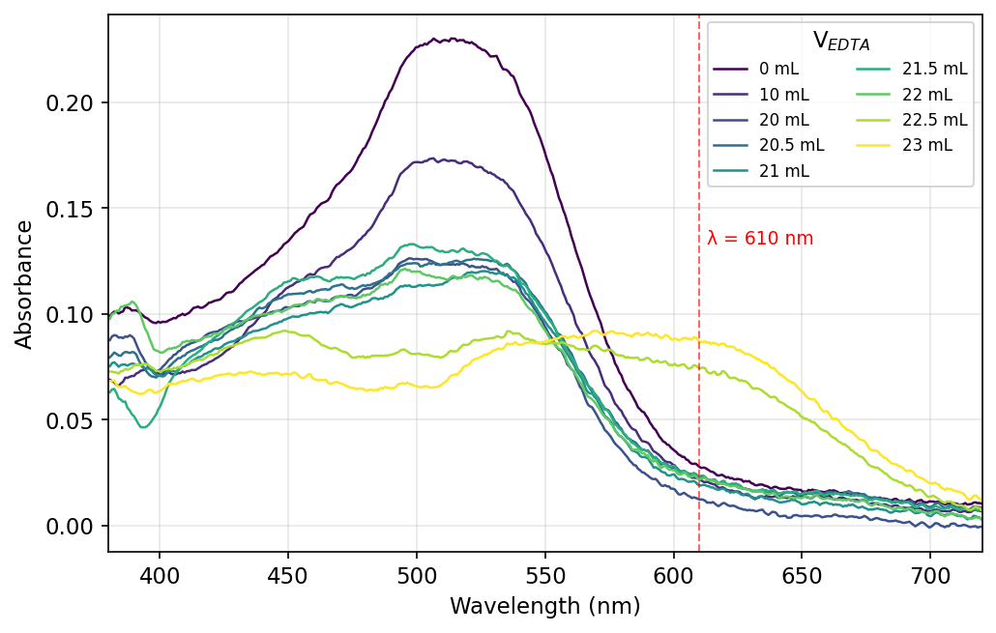
Figure 1. Absorbance spectra of the 0.0100 M ${\text{MgCl}}_{2}$ solution after addition of 0–23 mL of 0.0100 M EDTA. The wine-red Mg–Calmagite band at $λ≈510$ nm decays as EDTA strips ${\text{Mg}}^{2+}$ from Calmagite, and past the visual endpoint (22.2 mL) a blue free-Calmagite band rises near 610 nm — the dashed vertical line marks the tracking wavelength used in Q2.
The post-endpoint spectrum recorded at V = 28 mL was excluded on physical-chemical grounds: it shows $A_{500}=0.299$, higher than the V = 0 spectrum, which is impossible under dilution plus EDTA consumption and indicates a cuvette/sample-handling error during that single acquisition.

Q2. Absorbance at 610 nm vs. volume of EDTA added (Part A standardization)
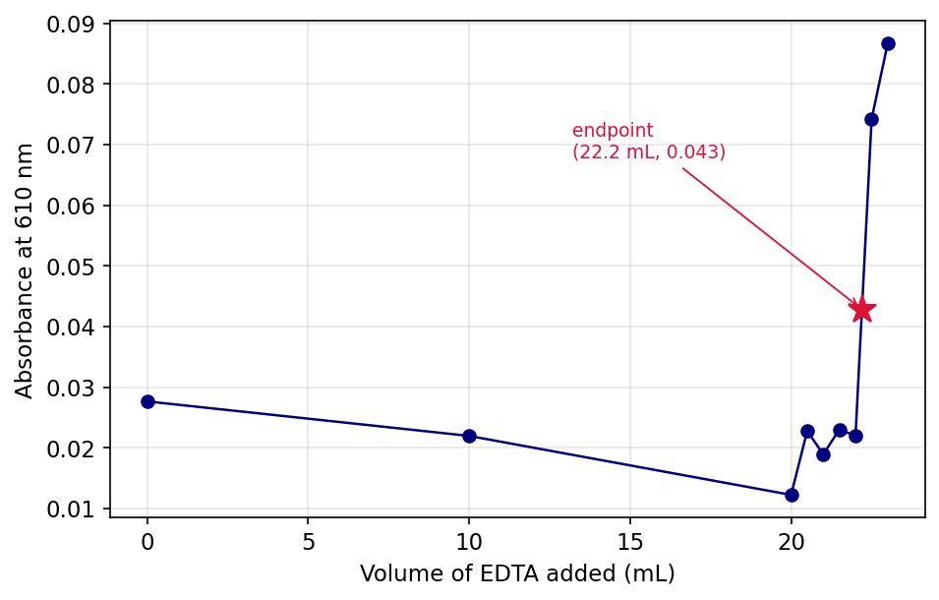
Figure 2. $A_{610}$ vs. volume of EDTA for the 0.0100 M ${\text{MgCl}}_{2}$ standardization. Absorbance stays near baseline until V = 22 mL, then jumps as free blue Calmagite forms; the star marks the visually recorded endpoint $(V_{eq},A_{610})=(22.2 \text{mL}, 0.043)$, with $A_{610}$ interpolated linearly between the bracketing spectra.

Q3. Average [EDTA] and 95 % CI from shared Part A data
I posted my Part A endpoint to the class-shared document, but no other groups had submitted Part A endpoint volumes at the time of writing. Following the precedent set in Lab 4 Q2 (graded full marks), I report $[\text{EDTA}]$ from my single trial and note that the 95 % confidence interval is undefined for $n=1$.
The stoichiometry is 1:1, so $n_{\text{EDTA}}=n_{{\text{Mg}}^{2+}}$ at the equivalence point:
$$[\text{EDTA}]=\frac{[{\text{Mg}}^{2+}]⋅V_{{\text{Mg}}^{2+}}}{V_{\text{eq}}}=\frac{(0.0100 \text{M})(25.00 \text{mL})}{22.2 \text{mL}}=0.0113 \text{M}$$
Single-trial value: $[\text{EDTA}]=0.0113$ M. Once additional class endpoints are posted, the average and 95 % CI will be computed as $\overset{‾}{x}±t_{0.05, n−1}⋅s/\sqrt{n}$.

Part B

Q4. Overlaid absorbance spectra of unknown ${\text{MgCl}}_{2}$/Calmagite at each titration point
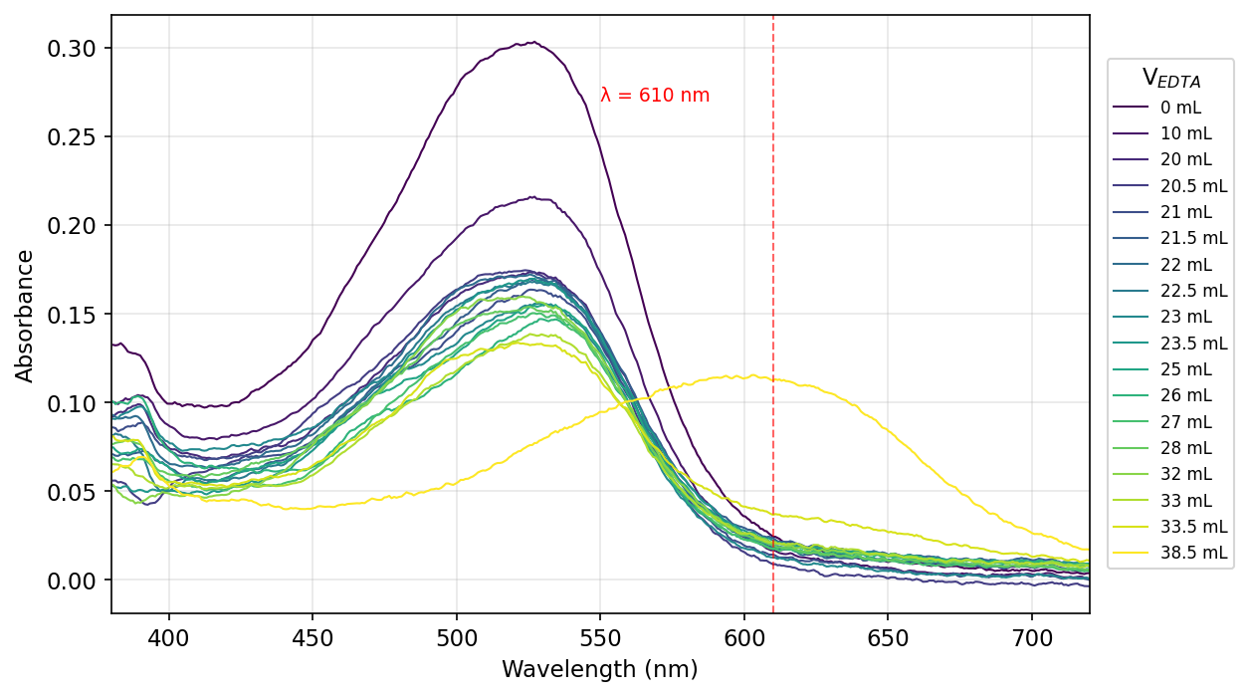
Figure 3. Absorbance spectra of the unknown ${\text{MgCl}}_{2}$ solution after addition of 0–38.5 mL of 0.0113 M EDTA. The wine-red Mg–Calmagite band at $∼525$ nm dominates from V = 0 to V = 33.5 mL; at V = 38.5 mL (5 mL past the visual endpoint) the spectrum shifts to a clear blue-Calmagite band centred at 603 nm. The dashed vertical line marks $λ=610$ nm, the tracking wavelength.

Q5. Absorbance at 610 nm vs. volume of EDTA added (Part B unknown)
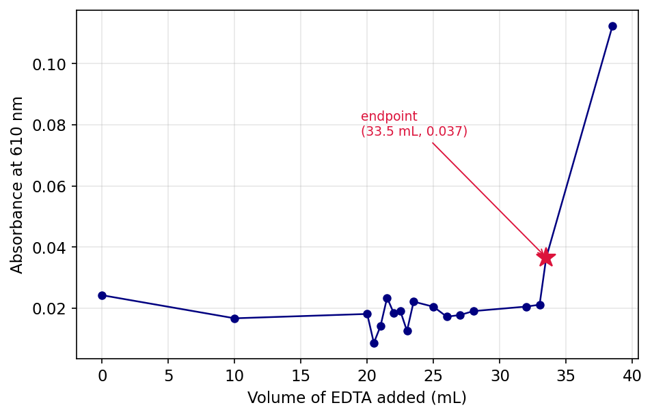
Figure 4. $A_{610}$ vs. volume of EDTA for the unknown ${\text{MgCl}}_{2}$. The titration shows a slow rise from 0.02 to 0.04 between V = 0 and V = 33.5 mL, then a sharp jump to 0.11 at V = 38.5 mL where the free blue Calmagite chromophore is fully formed. The endpoint annotation $(V_{eq},A_{610})=(33.5 \text{mL}, 0.037)$ corresponds to the volume at which the solution first turned blue in lab.

Q6. Average $[{\text{MgCl}}_{2}]$ of unknown and 95 % CI from shared Part B data
I posted my Part B endpoint to the class-shared document, but no other groups had submitted Part B endpoint volumes at the time of writing. Following the Lab 4 Q2 precedent, I report the single-trial concentration; the 95 % CI is undefined for $n=1$.
Using the $[\text{EDTA}]$ from Q3 and the 1:1 stoichiometry:
$$[{\text{MgCl}}_{2}]_{\text{unk}}=\frac{[\text{EDTA}]⋅V_{\text{eq}}}{V_{\text{unk}}}=\frac{(0.0113 \text{M})(33.5 \text{mL})}{25.00 \text{mL}}=0.0151 \text{M}$$
Single-trial value: $[{\text{MgCl}}_{2}]_{\text{unk}}=0.0151$ M.

Part C

Q7. Absorbance spectrum of the Mg(II)/HQS solution
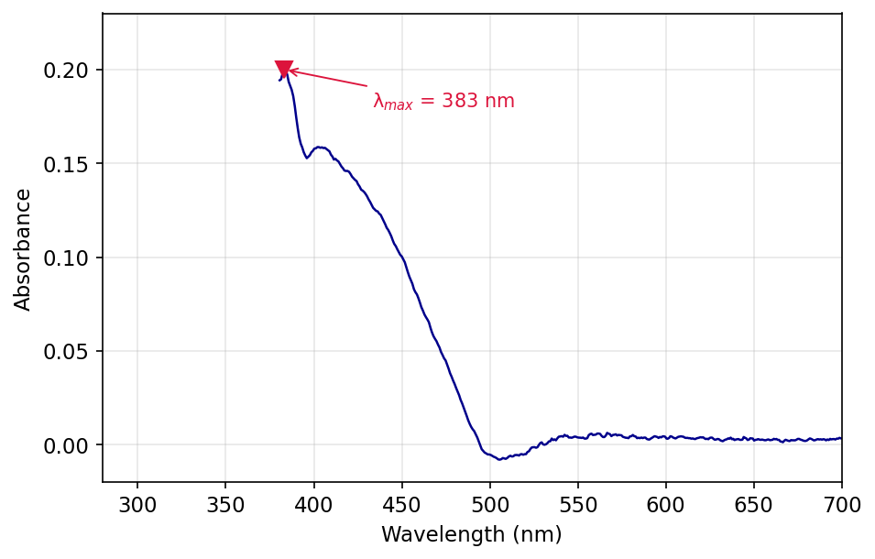
Figure 5. Absorbance spectrum of the unknown ${\text{MgCl}}_{2}$ aliquot mixed with 25 mL of 1 mM HQS. The $λ_{max}$ at 383 nm corresponds to the Mg–HQS $π→π^{*}$ transition; a smaller shoulder near 405 nm carries enough absorbance to be a useful excitation wavelength for fluorescence.

Q8. Choice of $λ_{\text{excitation}}$ (405 nm vs. 500 nm)
I used $λ_{\text{excitation}}=405$ nm. From Fig. 5, $A_{405}=0.16$ while $A_{500}≈0$, so the Mg–HQS complex absorbs only the 405 nm photons; exciting at 500 nm would deliver essentially no light to the chromophore and the fluorescence signal would be lost in noise.

Q9. Fluorescence spectrum of the unknown ${\text{MgCl}}_{2}$/HQS solution
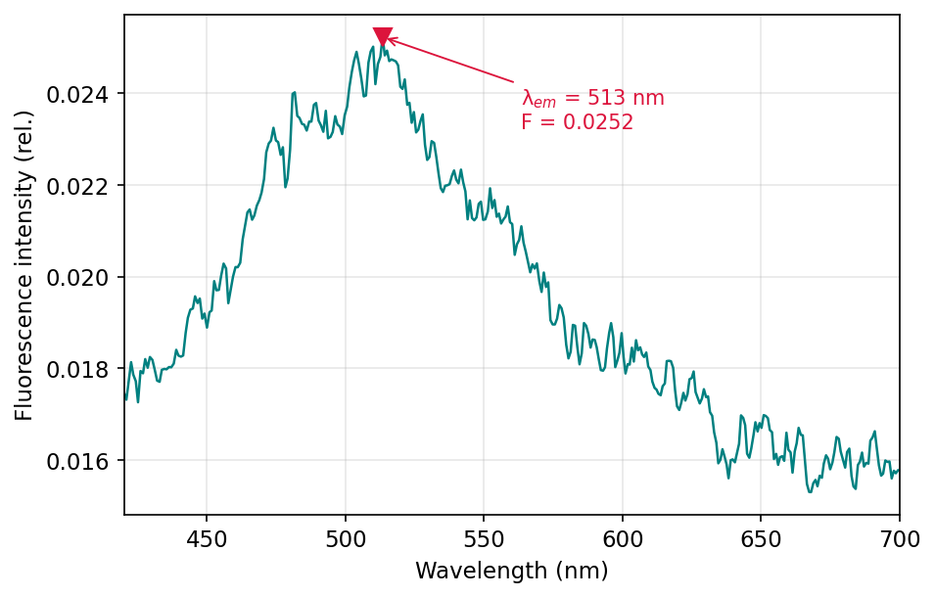
Figure 6. Fluorescence emission spectrum of the unknown Mg–HQS solution at $λ_{\text{excitation}}=405$ nm, showing $λ_{\text{emission}}=513$ nm with peak intensity 0.0252 (rel.). Two earlier acquisitions of the same solution gave 0.0233 and 0.0243, all three values falling below the 0.032–0.085 calibration window flagged in the manual.

Q10. Mg–HQS fluorescence calibration curve
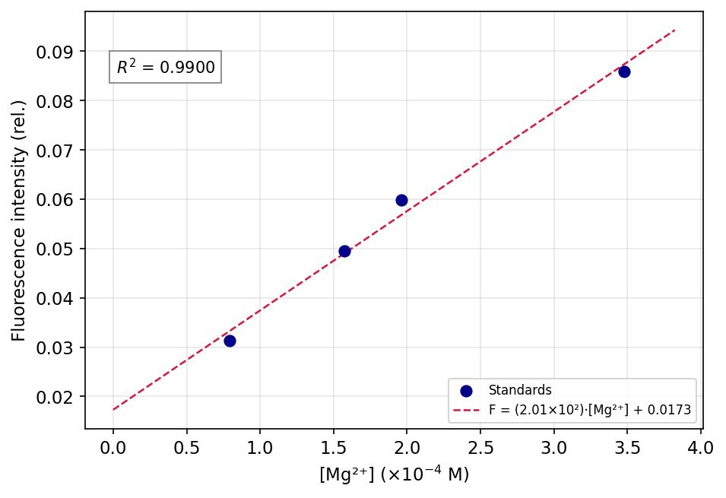
Figure 7. Fluorescence intensity vs. $[{\text{Mg}}^{2+}]$ for the four manual-provided standards, with linear best fit $F=(2.01×{10}^{2} {\text{M}}^{−1})[{\text{Mg}}^{2+}]+0.0173$ and $R^{2}=0.990$. Concentrations were computed from the stock 0.0100 M ${\text{MgCl}}_{2}$ aliquot diluted into HQS, e.g. $0.0100 \text{M}×0.8 \text{mL}/(0.8+100 \text{mL})=7.94×{10}^{−5} \text{M}$.

Q11. Slope and intercept with 95 % CI
For $n=4$ calibration points, $\text{df}=n−2=2$, $t_{0.05,2}=4.303$.
$$m=(2.0±0.6)×{10}^{2} {\text{M}}^{−1}$$
$$b=0.02±0.01 (\text{rel.})$$
Standard errors of regression: $s_{y|x}=2.79×{10}^{−3}$, $∑(x_{i}−\overset{‾}{x})^{2}=3.80×{10}^{−8} {\text{M}}^{2}$, giving ${SE}_{m}=14.3 {\text{M}}^{−1}$ and ${SE}_{b}=3.12×{10}^{−3}$. The 95 % CI half-widths are $t⋅{SE}_{m}=61.5 {\text{M}}^{−1}$ and $t⋅{SE}_{b}=0.0134$, rounded to 1 sf at the first non-zero digit.

Q12. Average $[{\text{MgCl}}_{2}]_{\text{unk}}$ and 95 % CI from fluorescence
No other groups had posted Part C fluorescence values for the same dilution at the time of writing. Following the Lab 4 Q2 precedent, I report the single-trial concentration; the 95 % CI here uses the calibration prediction-interval formula with $m=3$ replicate measurements of my own solution, but cannot reflect inter-group variation.
Mean unknown fluorescence: ${\overset{‾}{F}}_{\text{unk}}=(0.0233+0.0243+0.0252)/3=0.02427$.
Diluted concentration via inverse regression:
$$[{\text{Mg}}^{2+}]_{\text{diluted}}=\frac{{\overset{‾}{F}}_{\text{unk}}−b}{m}=\frac{0.02427−0.01730}{201.4 {\text{M}}^{−1}}=3.46×{10}^{−5} \text{M}$$
Standard error of the predicted $x$:
$$s_{x}=\frac{s_{y|x}}{|m|}\sqrt{\frac{1}{m_{\text{obs}}}+\frac{1}{n_{\text{calib}}}+\frac{({\overset{‾}{F}}_{\text{unk}}−{\overset{‾}{F}}_{\text{calib}})^{2}}{m^{2}∑(x_{i}−\overset{‾}{x})^{2}}}=1.55×{10}^{−5} \text{M}$$
The 95 % CI half-width is $t⋅s_{x}=4.303×1.55×{10}^{−5}=6.7×{10}^{−5}$ M, so $[{\text{Mg}}^{2+}]_{\text{diluted}}=(3±7)×{10}^{−5}$ M (rounded $x±u$ to 1 sf at the first non-zero digit of $u$).
The unknown aliquot was diluted 0.500 mL into 25.0 mL of HQS, so the dilution factor is $25.5/0.500=51.0$:
$$[{\text{MgCl}}_{2}]_{\text{unk}}=51.0×(3.46×{10}^{−5} \text{M})=1.76×{10}^{−3} \text{M}$$
with 95 % CI half-width $51.0×6.7×{10}^{−5}=3.4×{10}^{−3}$ M.
Single-trial value: $[{\text{MgCl}}_{2}]_{\text{unk}}=2 \text{mM}±3 \text{mM}$ (95 % CI). The CI is larger than the central value because ${\overset{‾}{F}}_{\text{unk}}=0.0243$ falls below the lowest calibration standard (0.0313); see Q14.

Discussion

Q13. Percent error for each method
The true unknown concentration provided by the TA is $[{\text{MgCl}}_{2}]_{\text{true}}=0.0150$ M.
For EDTA titration (example calculation):
$$\% \text{error}=\frac{|x_{\text{exp}}−x_{\text{true}}|}{x_{\text{true}}}×100\%=\frac{|0.0151−0.0150|}{0.0150}×100\%=0.67\%→0.7\%$$
For HQS fluorescence:
$$\% \text{error}=\frac{|0.00176−0.0150|}{0.0150}×100\%=88\%→90\%$$
Both rounded to 1 sf at the first non-zero digit. The EDTA titration was far more accurate (0.7 % vs. 90 %).

Q14. One hypothesized source of error for each method
EDTA titration: the equivalence point was read visually from the wine-red → blue colour change of Calmagite. Reading the volume at the first visibly blue drop has roughly $±0.2$ mL uncertainty out of $∼22–34$ mL, which translates to about $±1\%$ on the back-calculated concentration — enough to account for the observed 0.7 % deviation.
HQS fluorescence: the unknown’s measured intensity (0.024) fell below the lowest calibration standard (0.031), so the back-calculation extrapolates outside the linear range. Combined with only four calibration points (df = 2), the prediction interval is wide enough to swallow the true value, and any small systematic offset — e.g. a slight pH drift away from 8 between standards and unknown, or incomplete mixing of the 500 µL aliquot — gets amplified by the 51× dilution factor on the back-calculation.

Q15. State of ${\text{Mg}}^{2+}$ before, during, and after the EDTA endpoint (Parts A/B)
Before any EDTA is added, ${\text{Mg}}^{2+}$ is partitioned between the aquated free ion in the buffered solution and a small fraction bound to Calmagite as the wine-red $\text{Mg–Calm}$ complex. As EDTA is titrated in, it sequesters the free ${\text{Mg}}^{2+}$ first because $K_{f}({\text{MgY}}^{2−})≈{10}^{8}$ is far larger than the binding constant of either water or Calmagite; once the free pool is depleted the next EDTA additions strip ${\text{Mg}}^{2+}$ off Calmagite to make the colourless ${\text{MgY}}^{2−}$ complex. The endpoint is reached when all ${\text{Mg}}^{2+}$ in solution — both free and Calmagite-bound — is locked into ${\text{MgY}}^{2−}$, leaving Calmagite in its uncomplexed blue form. After the endpoint any further EDTA stays unreacted, since there is no remaining ${\text{Mg}}^{2+}$ to bind.

Q16. State of ${\text{Mg}}^{2+}$ before and after HQS is added (Part C)
In the original unknown solution ${\text{Mg}}^{2+}$ is fully aquated as $[\text{Mg}({\text{H}}_{2}\text{O})_{6}]^{2+}$, non-fluorescent on its own. After the 500 µL aliquot is mixed into 25 mL of 1 mM HQS at pH $≈8$, HQS displaces several water ligands and chelates ${\text{Mg}}^{2+}$ through its phenolate oxygen and pyridine nitrogen, forming the rigid Mg(HQS)$​_{2}$ complex. The locked geometry suppresses non-radiative decay, so the complex emits strongly at 513 nm under 405 nm excitation; the fluorescence intensity is then proportional to the bound-Mg concentration over the linear range of the calibration.

Instrumentation

Q17. What is HQS, and how is it different from EDTA?
HQS is 8-hydroxyquinoline-5-sulfonic acid, a bidentate chelating ligand that binds ${\text{Mg}}^{2+}$ through its phenolate-O and ring-N atoms to make a rigid complex that fluoresces under UV/near-UV excitation. EDTA is a hexadentate ligand whose four carboxylates and two amines wrap a single metal ion in a colourless, octahedral cage. EDTA’s six donor atoms give a much higher formation constant ($K_{f}∼{10}^{8.7}$ for ${\text{MgY}}^{2−}$ vs. $∼{10}^{4−5}$ for Mg-HQS), so EDTA is used as the stoichiometric titrant; HQS is used as the spectroscopic probe — the complex’s fluorescence, not its binding strength, is what we measure.

Q18. Why use a buffer in Parts A and B, and why check the pH in Part C?
EDTA exists as ${\text{H}}_{4}\text{Y}$, ${\text{H}}_{3}{\text{Y}}^{−}$, ${\text{H}}_{2}{\text{Y}}^{2−}$, ${\text{HY}}^{3−}$, or ${\text{Y}}^{4−}$ depending on pH, and only the fully deprotonated ${\text{Y}}^{4−}$ chelates ${\text{Mg}}^{2+}$ effectively. The conditional formation constant therefore rises with pH — but above pH 10, ${\text{Mg}}^{2+}$ starts to precipitate as ${\text{Mg(OH)}}_{2}$ and no longer reacts with EDTA. The ${\text{NH}}_{4}\text{OH}$ buffer in Parts A and B holds the solution at pH 10 to maximise $[{\text{Y}}^{4−}]$ without losing ${\text{Mg}}^{2+}$ to hydroxide precipitation. In Part C the issue is different: Mg–HQS fluorescence intensity peaks at pH 8 and falls off sharply outside a narrow window, so we check the pH paper to confirm the solution lands in that range before the calibration curve becomes meaningful. Outside pH 8 the Mg–HQS complex either dissociates (low pH) or competes with Mg(OH)$​_{2}$ formation (high pH), and the standard-vs-unknown comparison breaks.

